Project Design Phase-II
Technology Stack (Architecture & Stack)

Date | 07 March 2026
Project Name | Visualization Tool for Electric Vehicle Charge and Range Analysis
Maximum Marks | 4 Marks

Technical Architecture:
The Deliverable shall include the architectural diagram as below and the information as per the table1 & table 2

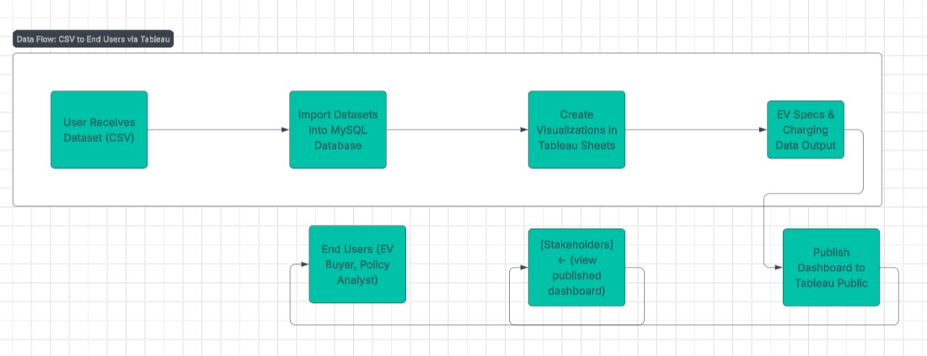

Table-1 : Components & Technologies:
S.No | Component | Description | Technology Used
1 | User Interface | Tableau Dashboard accessed via web | Tableau Public (Web UI)
2 | Application Logic-1 | Data filtering, sorting, and KPI logic | Tableau Calculations
3 | Application Logic-2 | Dashboard interactions (filters, stories) | Tableau Sheets/Story Functions
4 | Database | Stores EV specs, charging station data | MySQL
5 | Cloud Database | Not applicable | —
6 | File Storage | Raw data files (.csv) | Local Filesystem
7 | External API-1 | Not used | —
8 | External API-2 | Not used | —
9 | Machine Learning Model | Not used | —
10 | Infrastructure | Tableau Desktop on Local + Tableau Public | Local PC, Tableau Cloud

Table-2: Application Characteristics:

S.No | Characteristics | Description | Technology Used
1 | Open-Source Frameworks | Data cleaned using open-source spreadsheet tools | LibreOffice / Python (optional)
2 | Security Implementations | Public view only (read-only), no login required | Tableau Public default
3 | Scalable Architecture | Easily expandable by adding more datasets/visuals | Tableau architecture
4 | Availability | Always available via Tableau Public (hosted dashboard) | Tableau Cloud
5 | Performance | Light-weight dashboard, optimized for fast loading | Tableau engine, MySQL backend

